FRONT END – PART 1
STYLING WITH CSS

(Opacity)
1. Which CSS property sets the element’s opacity to 25%?
a) opacity: 25% b) opacity: 25;
c) opacity: 0.25; d) opacity: ¼;
SOLUTION DESCRIPTION:
Explanation: The value of opacity lies between 0.0 to 1.0 where a low value represents high transparency and a high value represents low transparency.
percentage of opacity is calculated as Opacity% = Opacity * 100.

(Color it Blue)
2. Which of the following will give blue color to text?
a) color: blue; b) color: hsl(255, 0, 0);
c) color: hsl(0, 255, 0); d) color: rgba(0, 0, 255, 1);
e) color: rgba(0, 0, 255, 0);

(Color the Paragraph)
3. How will you make all paragraph elements 'RED' in color ?
a) p { color: red; } b) p { color:rgb(255,0,0); }
c) p { color: rgba(255,0,0,1); } d) all of the above

(Dynamic Width)
4. What should be the value of the width attribute, so that the width of the element adjusts itself to the current width of its parent element?
a) 100rem b) 100%
c) 100vw d) 100em
SOLUTION DESCRIPTION:
A width set in percent (%) is relative to the width of the parent element, but a width set in 'vw' is relative to the entire viewport width.

(CSS Unit)
5. Which of the following measurements is relative to the font-size of the root element?
a) em b) rem
c) px d) %

(Viewport)
6. Which of the following measurements is relative to 1% of the width of the viewport?
a) vh b) vw
c) rem d) em

(Dotted Border)
7. If we want to use a dotted border around an image, which css property will we use?
a) border-color b) border-decoration
c) border-style d) border-line

(Bottom Left Corner)
8. Identify the CSS property defining bottom-left corner shape of the border?
a) border-radius b) border-bottom-left-radius
c) border-bottom-corner-radius d) border-left-radius

(Border Bottom)
9. Select the CSS property that sets the width of an element’s bottom border?
a) border-width b) border-bottom
c) border-width-bottom d) border-bottom-width

(Color the Text)
10. Which CSS property is used to change the text color of an element?
a) text-color b) font-color
c) color d) bgcolor

(Make it Bold)
11. What is the correct CSS syntax for making all the <p> elements bold?
a) p { font-weight:bold; } b) <p style=”font-size:bold;”>
c) p { text-size:bold; } d) <p style=”text-size:bold;”>

(Remove Underline from Link)
12. By default Hyperlinks are displayed with an underline. How do you remove the underline from all hyperlinks by using CSS code?
a) a { underline:none; } b) a { text-decoration:no-underline; }
c) a { decoration:no-underline; } d) a { text-decoration:none; }

(Make Text Italic)
13. Which property is used to display the text in italics?
a) font-family b) font-style
c) font-weight d) text-style

(Capitalize Text)
14. How do you make each word in a text start with a capital letter?
a) text-transform:capitalize b) text-style:capitalize
c) font-style:capitalize d) transform:capitalize

(Text Sizing)
15. Which CSS property controls the text size?
a) text-style b) font-size
c) font-style d) text-size

(Color the Background)
16. How do you add a background color for all <h1> elements?
a) all.h1 { background-color:#FFFFFF; } b) h1 { background-color:#FFFFFF; }
c) h1.all { background-color:#FFFFFF; } d) none of the above

(Set Background Image)
17. Which CSS property sets a background image for an element?
a) background b) background-attachment
c) background-color d) background-image

(Control Image Scroll)
18. Which of the following property is used to control the scrolling of an image in the background?
a) background-attachment b) background
c) background-repeat d) background-position

(Background Images)
19. Can we set more than one background image?
a) Yes b) No
SOLUTION DESCRIPTION:
Yes, we can have multiple background images like the code below -

div {
...
background-image: url("https://secure.gravatar.com/avatar/a07645826af48a15e1c6ce2869f2083b?s=49&d=identicon&r=g") ,url("https://blog.codingninjas.in/wp-content/uploads/2017/01/cropped-Final_logo_switchtocode-01.png");
...
}

(Space Between Elements)
20. Which property is used to give space between elements?
a) padding b) indent
c) margin d) gap

(Margin Value)
21. Can you use negative values in margin property?
a) Yes b) No

(Auto Margin)
22. What does the ‘margin:auto’ means?
a) Set the margin equally on top and bottom of the element
b) Set the margin equally on left and right of the element
c) Set the margin equally on all sides of the element.
d) It is uncertain what will happen
SOLUTION DESCRIPTION:
Explanation: ‘margin:auto’ makes the element come in the center within its container (parent element).

(Provide Some Space)
23. Which property is used to give space between content and border?
a) margin b) indent
c) padding d) gap

(Negative Padding)
24. When using the padding property; are you allowed to use negative values?
a) Yes b) No
SOLUTION DESCRIPTION:
Explanation: No, Negative values are not allowed for padding property. Negative values are ignored or treated as 0, which could have the same effect: none.

(Set the Padding)
25. If an element have padding values 20px for top, 30px bottom, 15px for right, 10px for left.
Then which of the following is the correct way to set that padding?
a) padding: 20px 30px 15px 10px b) padding: 20px 15px 30px 10px
c) padding: 15px 30px 10px 20px d) padding: 30px 15px 20px 10px

(How it Looks?)
26. There is a span element with the following CSS properties applied to it:

span {
display: block;
margin: 50px 0;
padding: 0;
color: red;
}

What all will be true about it?
a) element will cover the full width available b) element will cover the full height available
c) element will leave some spacing around it d) element will start from a new line
e) margin property won’t work

(Invisible Element)
27. If an element becomes invisible but the rest of the web page layout is not affected, then what could be the property applied to that element?
a) display: none; b) visibility: hidden;
c) display: hidden; d) visibility: none;

(Check Display)
28. There are two paragraphs with different colors, as shown in the figure below.
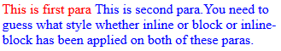
What is the value of the ‘display’ attribute in the paras respectively?
Note: You must ensure by adjusting the viewport and choosing the option accordingly.
a) inline and inline-block b) block and inline
c) inline and inline d) inline-block and inline
SOLUTION DESCRIPTION:
inline and inline-block will give the expected output as shown in the image, but if we decrease the viewport width of the screen, the 2nd para element will be seen in the next line and NOT in the same line because of the reason (The browser reads the content inside the p tags as a single unit and creates a box on the browser screen corresponding to it. While displaying, this box will have a certain width depending on the length of content written inside the p tags. If the length of the content exceeds the viewport width, then the browser WON'T automatically fill the next line in the browser, rather continue filling the content to the left (hence a horizontal scroll bar will also appear).
Hence if two para tags with display property inline appear together, and the 2nd one has content length exceeding the viewport width, then it'll appear on the next line despite being inline (because the box created for this p element won't occur in breaks).
But this is not the case for inline-block and inline since the content of the first para element is small (won't take up the entire viewport width), and once it ends the 2nd para element will be shown in continuation giving output as given in the output.

(Default Position)
29. What is the default value of the position property?
a) absolute b) fixed
c) static d) relative

(Fix the Element)
30. Which value of position always fixes the position of the element relative to the viewport?
a) absolute b) fixed
c) static d) sticky

(Sticky Position)
31. The element shown below has property 'position:sticky' set and is 50px below from the top of the screen initially.
How will the element look like initially and after scrolling 50px down ?

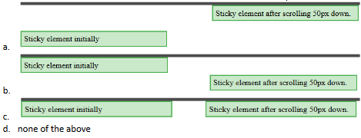
a) b b) a
c) d d) c

(Total Width)
32. Which of the following does not count in the total width of the element in the web page?
a) border b) margin
c) padding d) none of the above

(Equal Dimension)
33. The 2 divs are given same width, height and border. The second div is given an extra padding of 40px and they show in the browser as:

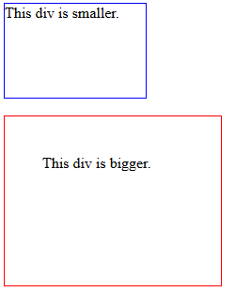
Which of the following property when added will make them of equal width and height like:

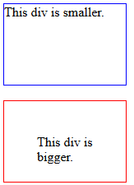
a) box-sizing: equal-box; b) box-sizing: content-box;
c) box-sizing: border-box; d) box-sizing: same-box
SOLUTION DESCRIPTION:
The box-sizing property includes the element’s padding and border in an element's width and height.

(Least Width)
34. Which property will be used to display an image of at least 100px width?
a) max-height b) max-width
c) min-height d) min-width

(Boundary Exceeded)
35. If the width of an element is exceeded by the content of the element, then which property will define the behaviour of the content?
a) overflow-y b) overflow-x
c) overflow-width d) overflow

ASSIGNMENT

(Wrong Value)
36. Which of the following is not a value for font-style property?
a) normal b) italic
c) oblique d) none of the above

(Text Decoration)
37. Which of the following is not used with text-decoration property?
a) overline b) underline
c) line-through d) inline
SOLUTION DESCRIPTION:
text-decoration property is used to style text. So, 'overline', 'underline' and 'line-through' are the values of text-decoration property. While, 'inline' is value for display property.

(About Margins)
38. Which of the following options is correct for the following statements:

1) Vertical margins add together
2) Horizontal margins add together

a) Statement 1) is correct and 2) is incorrect b) Statement 1) is incorrect and 2) is correct
c) Statement 1) and 2) are both correct d) Statement 1) and 2) are both incorrect

(Set the Margin)
39. If an element have margin values 20px for top, 20px for bottom, 30px for right, 30px for left.
Then which of the following is the correct way to set the margin?
a) margin: 20px 20px 30px 30px b) margin: 30px 20px
c) margin: 20px 30px d) margin: 30px 30px 20px 20px
SOLUTION DESCRIPTION:
Explanation: Here top-bottom and left-right margins value same respective, so the correct way to set margin is:
margin : top_bottom left_right;
the first value will apply to the top and bottom of the box. The second value will apply to the left and right sides of the box.

(Resize the Size)
40. If the background image is of larger or smaller size than the container width, then which line of code will resize it to make fully visible?
a) background-size: contain; b) background-repeat: no-repeat;
c) background-size: cover; d) none of the above
SOLUTION DESCRIPTION:
Explanation: background-size: contain value is used to scale the image within its container without cropping or stretching the image, and in this case, the image is also fully visible.

(Changed Layout)
41. For the code:

<div>This is div.</div>
<span>This is span.</span>
<p>This is para.</p>

the page is as shown in figure below:
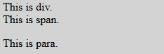
How will the page look like, when the <span> and <p> elements are moved inside the <div> element and ‘display:inline;’ style is added to the <div> element?

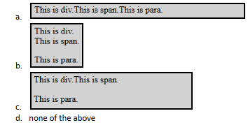
a) b b) a
c) d d) c

(Text Direction)
42. Can we define the direction of text via CSS property?
a) Yes b) No
SOLUTION DESCRIPTION:
The text direction can be set using the 'direction' property.

(Position Mixture)
43. The 3 boxes with the position value set are shown on web page as:
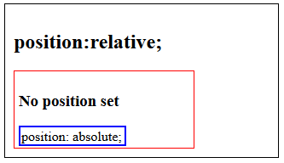
If the property “top: 0;” is added to element with blue border, then how will it be shown on the web page?
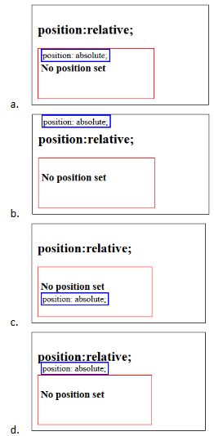
a) b b) a
c) d d) c

(Setting the Widths)
44. Can we set min-width and max-width for an element at the same time?
a) Yes b) No

**********

